**Author's personal copy**

**Provided for non-commercial research and educational use only.**

**Not for reproduction, distribution or commercial use.**

This chapter was originally published in the book *Artificial Photosynthesis, Volume*

*79*. The copy attached is provided by Elsevier for the author's benefit and for the benefit of the author's institution, for non-commercial research, and educational use. This includes without limitation use in instruction at your institution, distribution to specific colleagues, and providing a copy to your institution's administrator.

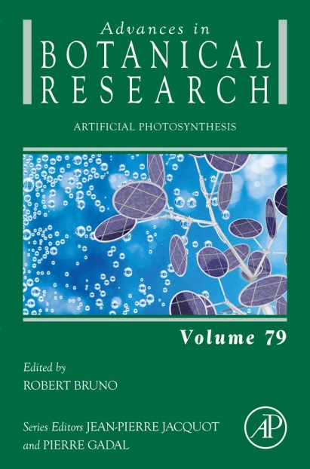

All other uses, reproduction and distribution, including without limitation commercial reprints, selling or licensing copies or access, or posting on open internet sites, your personal or institution’s website or repository, are prohibited. For exceptions, permission may be sought for such use through Elsevier’s permissions site at:

<http://www.elsevier.com/locate/permissionusematerial>

From van Stokkum IHM, Ravensbergen J, Snellenburg JJ, van Grondelle R, Pillai S, Moore TA, Gust D, Moore AL, Kennis JTM (2016) Chapter Six - Resolving Energy and Electron Transfer Processes in Dyads With the Help of Global and Target Analysis. In: Robert B (ed) Advances in Botanical Research, Volume 79. Academic Press, pp 169-192. doi:http://dx.doi.org/10.1016/bs.abr.2016.04.003

.

ISBN: 9780128032893

Copyright © 2016 Elsevier Ltd. All rights reserved.

Academic Press

This is the correct reference, according to the web site : http://www.sciencedirect.com/science/article/pii/S0065229616300623