Supporting Information
Excitation-induced polarization decay in the plant light-harvesting complex LHCII

Alessandro Marin, Ivo H.M. van Stokkum, Vladimir I. Novoderezhkin, Rienk van Grondelle

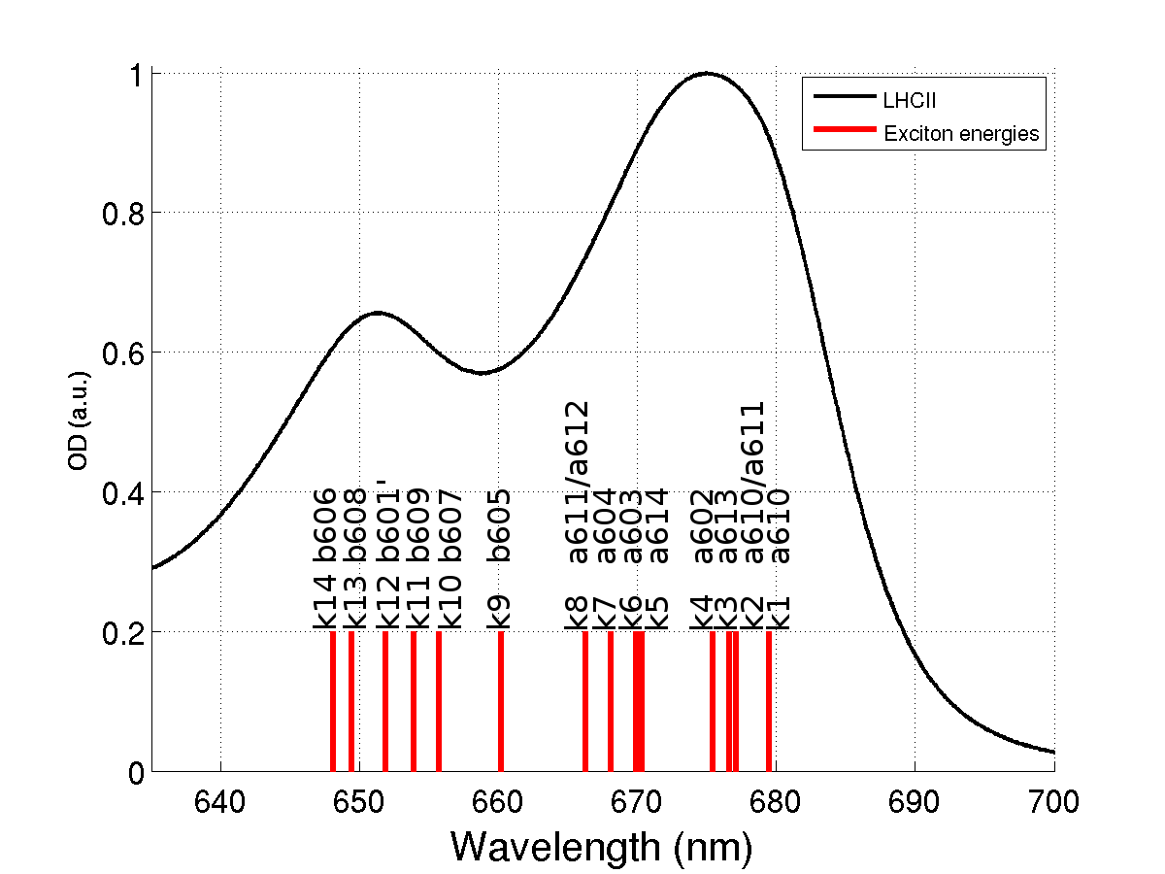

FIGURE S1. Steady state absorption of LHCII and ensemble averaged exciton energies from [16]. The label indicates the Chls having the highest participation ratio to each exciton level.

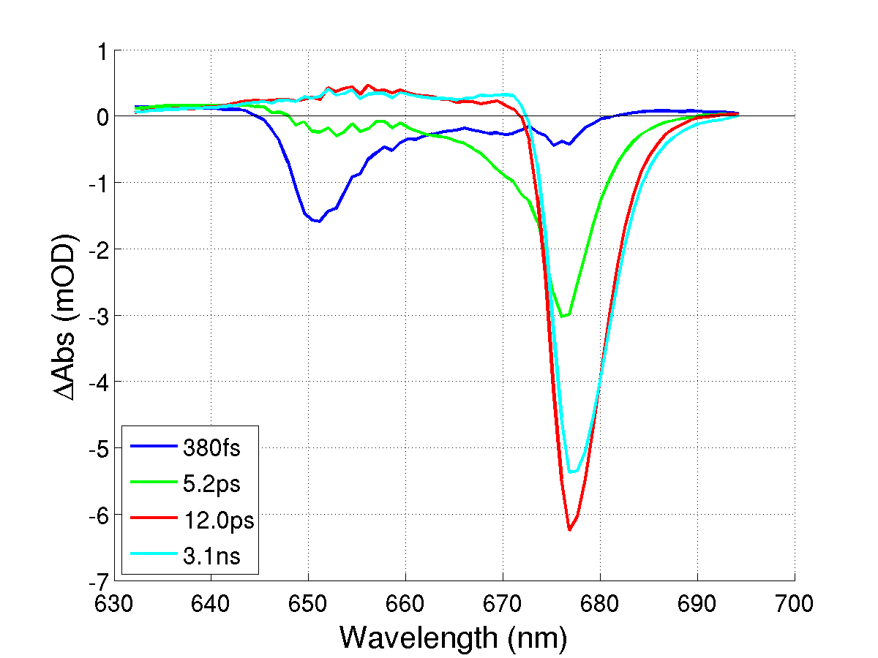

FIGURE S2. EADS and lifetimes estimated from independent global analysis at Magic Angle polarization after 652 nm excitation.

FIGURE S3. The complete set of kinetic traces for parallel (black), perpendicular (red) and Magic Angle (blue) measurements after 652 nm excitation. Solid lines indicate the measured data, and dashed lines correspond to the simultaneous target analysis fit. Note that the time axis is linear until 0.3 ps, and logarithmic thereafter.

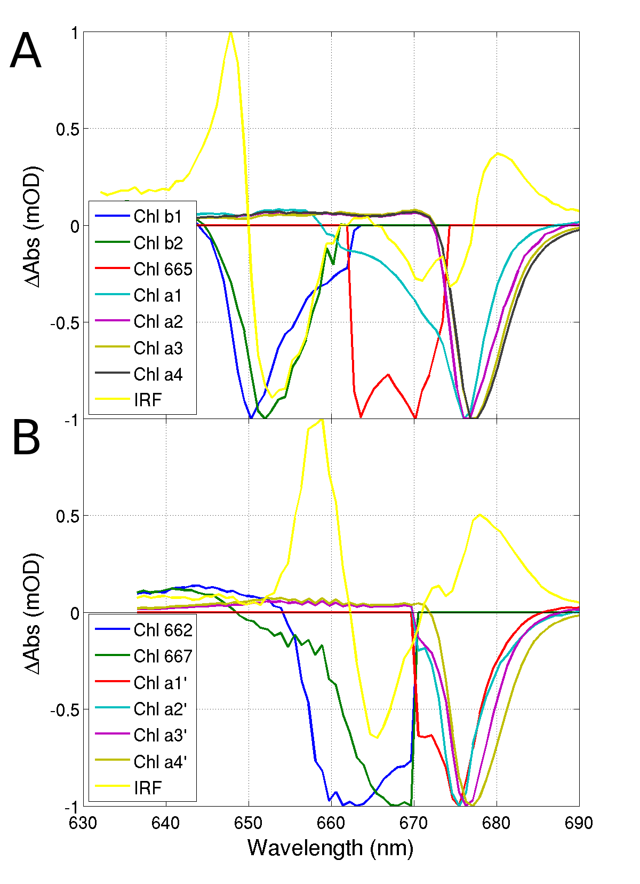

FIGURE S4. Normalized SADS estimated from the target analysis of the 652 (A) and 662 (B) nm excitation data sets. The SADS of the coherent artifact signals (IRF, spectrum in yellow) are dominated by a large wiggle around the excitation wavelength.

